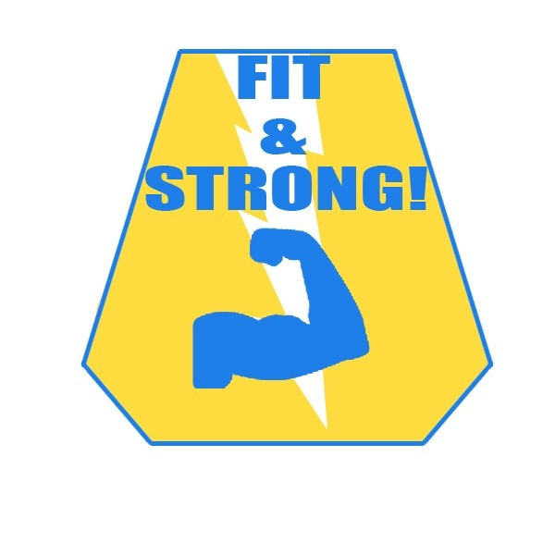

DO YOU HAVE **PAIN** OR **STIFFNESS**

IN YOUR LOWER BODY?

**TO IMPROVE THE QUALITY OF YOUR LIFE**

**Fit & Strong! is an exercise/behavior change program for older adults with lower extremity osteoarthritis.**

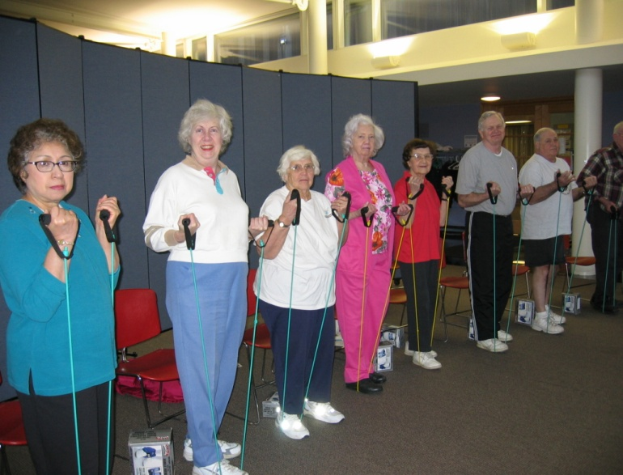

Fit & Strong! includes 60-minutes of exercise, and 30-minutes of group discussion/health education.

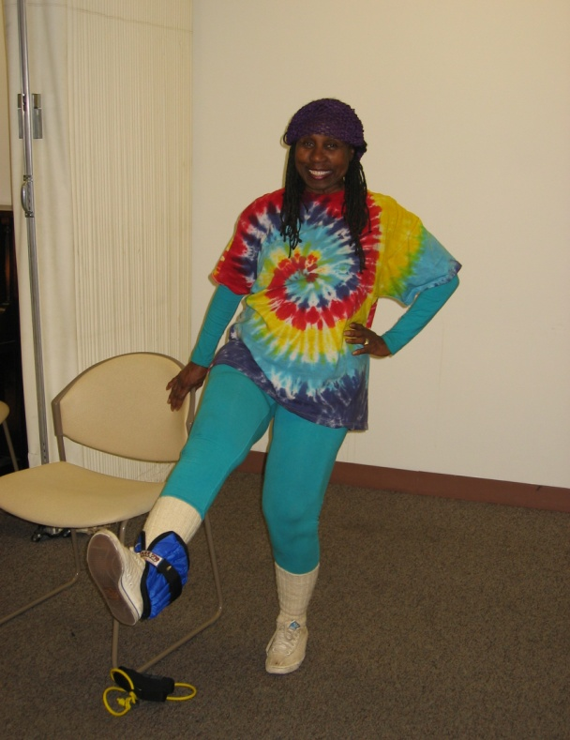

<<Add your Fit & Strong! program information here>>

**FIT & STRONG!** IS AN **AWARD-WINNING**

PROGRAM DESIGNED TO MEET YOUR NEEDS!

**Benefits to YOU**

**Fit & Strong! will help you:**

* Manage arthritis
* Exercise safely
* Decrease joint pain & stiffness
* Improve daily function
* Reduce anxiety & depression
* Develop & *maintain* an active lifestyle